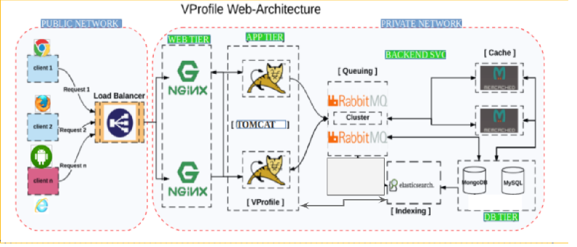

- Nginx – ubuntu
- Tomcat – Centos7
- RabbitMq – centos7
- Memcahce – centos7
- DB – centos7

